Optimizing the Small Council
A Genetic Algorithm Approach to Westerosi Governance and Human Resource Scheduling

1. Introduction and Problem Description
Scheduling a council of advisors, generals, and spies is a classic resource-constrained assignment problem: a fixed set of tasks must each be given a time, a place, and a group of attendees, while a much larger pool of people compete for the same handful of time slots. We use the small council of the War of the Five Kings as a stand-in for this problem: nine tasks (war councils, diplomatic missions, reconnaissance, and so on) must each be assigned exactly one of ten time slots, one of ten locations, and a group of attendees drawn from a cast of twenty-five characters, so as to maximize an overall value score while respecting a mix of hard constraints (who must attend, who is banned, who is even available) and soft preferences (who likes or dislikes whom, favourite locations and time slots).
The three assignment dimensions - time slot, location, and attendees - are not independent, and attendee choice alone ranges over an enormous number of subsets per task, so exhaustive search is infeasible. We instead solve the problem with a genetic algorithm (GA), implemented as an island model for parallel search, and use this report to document the representation, fitness function, and genetic operators, together with three design comparisons we ran along the way: random vs. heuristic population initialization, biased vs. non-biased mutation, and a sweep over the mutation-ratio hyperparameter.

2. Dataset
The problem instance lives in task_scheduling.json and has four parts:
- 9 tasks, e.g. War Council (value 10, requires Daenerys Targaryen and Tyrion Lannister) and Wight Recon Mission (value 10, requires Jon Snow and Tormund Giantsbane), down to smaller tasks such as Library Research (value 6, requires Samwell Tarly). Every task additionally specifies min/max attendees, required people, forbidden people, preferred people, allowed/preferred locations, and preferred time slots.
- 25 characters (Jon Snow, Daenerys Targaryen, Tyrion Lannister, Sansa Stark, Cersei Lannister, ... Melisandre), each with a home location, a list of time slots at which they are available, preferred/disliked tasks, and lists of people they like or dislike - the latter two drive the sympathy/antipathy bonus described below.
- 10 time slots (Day1_AM ... Day5_PM, i.e. morning/afternoon over 5 days) and 10 locations (Dragonstone, Winterfell, King's Landing, Oldtown, Eastwatch, Casterly Rock, The Eyrie, Pyke, Riverrun, Storm's End).
- A scoring_suggestion block defining the bonus/penalty values used by the fitness function - see Section 3.

3. Chromosome Representation and Fitness Function
A candidate schedule (a “chromosome”) is a Python dict with one entry per task, e.g. {"War Council": {"timeslot": "Day1_AM", "location": "Dragonstone", "attendees": ["Daenerys Targaryen", "Tyrion Lannister", ...]}, ...}. A chromosome therefore has exactly 9 genes, each a (timeslot, location, attendees) triple.
Fitness is computed once per chromosome (_fitness() in island_worker.py) by summing the following costs:
Rule | Value
Task completed | + task value (6–10)
Preferred person present | +2 per person
Preferred location used | +2
Preferred time slot used | +1
Liked pair present together (bidirectional) | +2 per pair
Disliked pair present together (bidirectional) | −4 per pair
Required person missing | −100 per person
Forbidden person present | −100 per person
Disallowed location used | −20
Person scheduled while unavailable | −50 per person
Person double-booked in the same slot | −100 per redundant booking
Table 1. Fitness costs (bonuses and penalties) making up the objective function.
The hard-constraint penalties (−20 to −100) are an order of magnitude larger than the bonuses (+1 to +2), so the GA very quickly learns to satisfy required-people, location, and availability constraints, and then spends the remainder of its search budget squeezing out bonus points - principally the pairwise sympathy bonus. In our benchmarked schedule the fitness converges to 353 with zero constraint violations: a 74-point base value, roughly 48–89 points of preferred-person/location/time-slot bonuses, and the remaining 180–204 points from sympathy pairs. The sympathy term is therefore both the largest and the hardest single component to optimize, which is exactly why the mutation-operator work in Sections 4 and 6 focuses on it.

4. Genetic Operators

4.1 Selection
Parents are chosen by tournament selection: k individuals (k = 4 or 5, depending on the experiment) are sampled uniformly at random from the population and the fittest of the k is returned. Two independent tournaments produce the two parents used for one crossover/mutation step.

4.2 Crossover
We use a uniform, per-task crossover: for every task, a fair coin decides whether child 1 inherits that task's full (timeslot, location, attendees) assignment from parent 1 or parent 2, with child 2 receiving the complement. This is applied with probability crossover_rate (0.85 in all experiments below); otherwise the two parents are cloned unchanged into the next generation.

4.3 Mutation
Three mutation functions were implemented and compared: _mutate (biased) _mutate_half_biased and _mutate_non_biased. For every task in a chromosome, mutation is triggered with probability mutation_rate. If triggered, one of three dimensions is mutated: the time slot (replaced with a uniformly random slot), the location (replaced with a random allowed location for that task), or the attendee list. The dimension is drawn from the weighted list ["timeslot", "location"] + ["attendees"] × mutation_ratio, so attendees are mutated with probability mutation_ratio / (mutation_ratio + 2). This mutation_ratio parameter is the key knob studied in Section 7.
Once “attendees” is selected, the two mutation functions differ in which attendee-level operation is applied:
- Non-biased (_mutate_non_biased) picks uniformly among replace (swap a random attendee for a random eligible outsider), add (insert a random eligible outsider if below max_people), and remove (drop a random non-required attendee if above min_people).
- Biased (_mutate) offers the same three basic mutation operations as the unbiased version—replace, add, and remove—while also introducing two preference-aware replacement operators. replace_with_preferred replaces a randomly selected attendee with an available character from the task's preferred_people list. replace_with_friend replaces a randomly selected attendee with an available character who is liked by as many of the remaining attendees as possible; candidates are selected with probability proportional to the number of attendees that like them, thereby increasing the likelihood of creating positive pair bonuses. To bias the search toward these domain-specific mutations, each preference-aware operator is included three times in the random selection list, making preference-guided replacements approximately twice as likely as each individual basic operation (replace, add, or remove).
- Half_biased works the same way as Biased but replace_with_friend exchanges a random person with a friend of the exchanged person. It was hypothesized that replacement with a friend could lead to strong interwoven social nets, given the tribal nature of the friendship bonds
Plain add/remove mutations tend to waste computation once the GA has converged on task/location assignments: add is usually a no-op once a task is already full, and remove is almost immediately selected back out because it directly forfeits fitness.
Biased mutation was implemented because the dimensions timeslot and location were optimized far earlier than attendees. We were unsure if mutating using heuristics or just mutating the attendees more than the other dimensions is better. So we implemented both.

4.4 Elitism and the island model
The fittest elitism individuals of each generation are copied unchanged into the next generation. Beyond a single population, the algorithm runs as an island model: n_islands independent sub-populations of pop_per_island individuals evolve in parallel (one OS process per island, via Python's ProcessPoolExecutor) for migration_interval generations at a time. At the end of each round, the five fittest individuals of each island (“emigrants”) replace the five weakest individuals of the next island in a ring topology. Migration periodically reintroduces diversity and helps avoid premature convergence, at the cost of one synchronization point per round.

5. Population Initialization: Random vs. Heuristic
We compared two ways of building the initial population, keeping every other GA parameter fixed at n_islands=6, pop_per_island=80, mutation_rate=0.35, mutation_ratio=1, benchmarking against a target fitness of 353 over 10 seeded runs. With n_generations_total=600 and migration_interval=100 a total of 6 migrations were performed.

Method 1: fully random initialization (_rand_schedule_random_init)
Time slot, location, and attendees (up to max_people) are all chosen uniformly at random, with no regard to required, preferred, or forbidden lists. With n_generations_total=600 (6 migration rounds of 100 generations),
This method reached the benchmarked fitness of 353 in 9 of 10 runs. It took an average of 265.67 generations to compute a solution fith a fitness of 353. The average time was 62 seconds.

Method 2: heuristic initialization (_rand_schedule)
Required people are always seeded into a task first, preferred people are added next (up to max_people), and only the remaining seats are filled randomly.
This method reached the benchmarked fitness of 353 in 10 of 10 runs. It took an average of 153.80 generations to compute a solution fith a fitness of 353. The average time was 61 seconds.

Result:
Seeding required and preferred people directly, rather than relying on the GA to discover them from scratch, removes an entire heavily-penalized region of the search space starting from generation zero, which is the dominant reason for the speed-up: both methods reach the same success rate and final fitness, but the heuristic initializer gets there with far less search.
However the heuristic initialization was not proportionally faster in relation to the saved generations. This is likely due to the complex list comprehensions used to make the heuristic initialization.
It should be noted here that this result depends on the algorithm speed. Before improving the algorithm a heuristic implementation was very advantageous.
We learned from this that different initialization methods need to be tuned to the problem. An overly complex initialization might lose time if the algorithm itself is sufficiently fast. We also understand that a heuristic initialization is a dangerous thing to do since this depends on a developers understanding of the desired solution.
6. Parameter Study: Mutation Ratio
We evaluated the influence of the mutation_ratio parameter by testing the values ({1, 2, 3, 5, 10, 25, 35}). For each setting, the genetic algorithm was executed five times with different random seeds using n_islands = 4, pop_per_island = 80, n_generations_total = 2400, migration_interval = 400, mutation_rate = 0.35, and a target fitness of 353.

Mutation ratio | Success rate | Avg. generations to 353 |
1 | 100% | 237.4
2 | 100% | 207.2
3 | 100% | 583.8
5 | 100% | 288.8
10 | 100% | 654.2
25 | 100% | 957.4
35 | 80% | 1725.5

Table 2: Success rate and average convergence speed for different values of mutation_ratio (10 runs per setting).
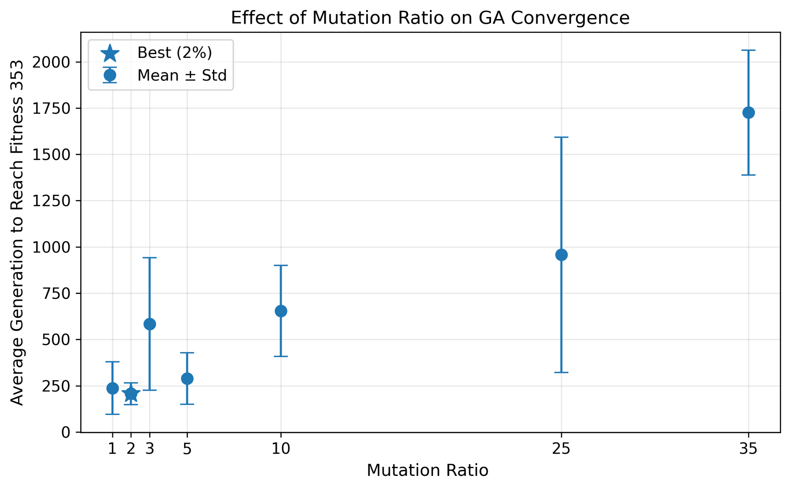
Figure 1: Average generation at which the target fitness of 353 was first reached for each mutation ratio (mean ± standard deviation over successful runs).

The results indicate that small mutation ratios lead to substantially faster convergence. A value of mutation_ratio = 2 achieved the best overall performance, reaching the optimal fitness in an average of only 207 generations while maintaining a 100% success rate. The neighbouring values mutation_ratio = 1 and mutation_ratio = 5 also converged reliably and rapidly, requiring on average 237 and 289 generations, respectively. In contrast, increasing the mutation ratio beyond 10 resulted in progressively slower convergence despite maintaining a perfect success rate up to mutation_ratio = 25. The largest value tested, mutation_ratio = 35, not only converged considerably more slowly (1,726 generations on average) but also reduced the success rate to 80%.

It should be noted that larger mutation_ratios were highly effective when the algorithm was run with _mutate_half_biased as mutation function. This was done to test the effectiveness of the mutation ratio when the algorithm optimizes the dimensions at different speeds. We went into this during our presentation. We learned that this can be a good technique to use when the different dimensions vary in complexity by a large amount. However this problem is solved using less resources and time via a biased mutation function.

7. Mutation Strategy: Biased vs. Non-biased

7. Mutation Strategy: Biased vs. Non-biased
We compared the two mutation operators, _mutate (biased) and _mutate_non_biased (non-biased), in a head-to-head evaluation over 10 runs each using different random seeds. The biased mutation operator incorporates domain knowledge by preferentially replacing attendees with either characters listed in a task's preferred_people set or characters that are liked by the remaining attendees in the group, thereby encouraging positive pair relationships. In contrast, the non-biased mutation operator performs only uniform random attendee replacements without considering these preferences.
They can both still add, and remove as well.
For both algorithms, the genetic algorithm was configured with n_islands = 6, pop_per_island = 80, mutation_rate = 0.35, and mutation_ratio = 2. The non-biased mutation operator was executed with n_generations_total = 2400 and migration_interval = 400, whereas the biased mutation operator used n_generations_total = 600 and migration_interval = 100. The objective in both experiments was to reach the optimal fitness value of 353.
Metric | Non-biased mutation | Biased mutation
Runs reaching fitness 353 | 10/10 (100%) | 10/10 (100%)
Mean best fitness | 353.0 | 353.0
Mean generations to 353 | 924.7 (SD 446.3) | 183.0 (SD 37.2)
Mean wall-clock time to 353 | 72.37 s (SD 36.54 s) | 18.96 s (SD 4.47 s)
Table 3: Comparison of biased and non-biased mutation over 10 seeded runs.
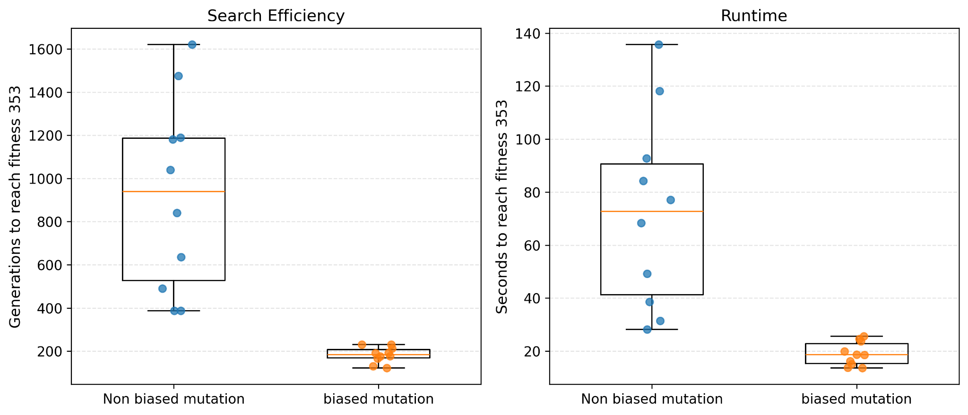
Figure 2. Generations (left) and wall-clock time (right) required to first reach the optimal fitness of 353. Individual points represent seeded runs, while the boxplots show the interquartile range.
Both mutation operators reached the optimal fitness in every run, demonstrating that introducing preference-guided mutations does not reduce the algorithm's ability to explore the search space or find optimal solutions. However, the biased mutation operator converged substantially faster. On average, it reached the optimum after only 183 generations compared with 925 generations for the non-biased operator, corresponding to an approximately 80% reduction in the number of generations required. A similar improvement is observed in wall-clock time: the biased operator required 18.96 seconds on average, compared with 72.37 seconds for the non-biased operator, representing a reduction of approximately 74%. This acceleration is expected because the biased mutation operator preferentially creates attendee combinations that are rewarded by the fitness function, increasing positive interpersonal relationships while still preserving sufficient randomness to explore alternative schedules.

8. Comparison of Variants and Overall Benchmarks
Table 4 summarizes the main experiments presented in this report. All experiments were performed using the same island-model genetic algorithm on the same hardware, with the objective of reaching the optimal fitness value of 353 while satisfying all hard constraints.
Variant | Islands × Population | Runs | Success rate | Mean convergence
Best mutation-ratio configuration | 4 × 80 | 5 | 100% | 207.2 generations at  (mutation_ratio = 2)
Heuristic initialization  Non-biased mutation | 6 × 80 | 10 | 100% | 924.7 generations / 72.37 s
Random initialization,  Biased mutation  (mutation_ratio = 2) | 6 × 80 | 10 | 90% | 265 generations / 61 s
Heuristic initialization  Biased mutation  (mutation_ratio = 2) | 6 × 80 | 10 | 100% | 183.0 generations / 18.96 s

Table 4. Overall comparison of the evaluated genetic algorithm variants.
The experiments consistently demonstrate that incorporating domain knowledge into the genetic algorithm substantially accelerates convergence while preserving solution quality. Preference-aware mutation significantly reduces both the number of generations and the wall-clock time required to reach the optimal solution without affecting the success rate. Likewise, the mutation-ratio study shows that a small value (mutation_ratio = 2) provides the best balance between exploration and exploitation, reaching the optimum considerably faster than larger values. Together, these results indicate that exploiting problem-specific knowledge during the search process is considerably more effective than relying solely on unbiased random mutations.

9. Conclusion and Future Work
The scheduling instance considered in this work combines several interacting constraints, including required and forbidden attendees, preferred and disliked pairings, individual availability, location restrictions, and penalties for double bookings. These constraints create a highly combinatorial search space in which the genetic algorithm must simultaneously satisfy hard constraints while maximizing several soft preference criteria.
Across all experiments, the island-model genetic algorithm consistently found the optimal solution. The results show that incorporating domain knowledge into the mutation operator provides the greatest performance improvement, reducing the average convergence time by approximately 80% in generations and 74% in wall-clock time compared with an unbiased mutation strategy. Furthermore, tuning the mutation ratio revealed that emphasizing attendee mutations only moderately (mutation_ratio = 2) leads to the fastest and most reliable convergence.

